**Objective:**

Matching 2D plane strain PEFIT dynamic responses (vertical stress and pore pressure) with 3D axisymmetric PEFIT. Two parameters were varied:

1) **length of loading area**

2) **hydraulic conductivity**

**Main conclusion of the parametric study**

1. Value of parameters that make 2D PEFIT yields closest dynamic responses (vertical stress and pore pressure) to 3D axisymmetric case are shown in table 1.

Please note that:

* The results of 2D still do not match results of axisymmetric satisfactorily
* Matching varies with depth, load length and hydraulic conductivity as can be seen in table 1.

**Table 1.** parameters used in 2D PEFIT

|  |  |  |  |  |
| --- | --- | --- | --- | --- |
|  |  | Load length (L, in) | Hydraulic conductivity (HC, in/s) | Reference |
| Vertical stress | Top | around 4 | - | Figure 3 a1 |
| Middle | 3-4 | - | Figure 3 b1 |
| Bottom | 2-3 | - | Figure 3 c1 |
| Pore pressure | Top | 1 | 0.0077 in/s | Figure 4 a |
| Middle | 1 | 0.015 in/s | Figure 5 b2 |
| Bottom | 1 | 0.015 in/s | Figure 5 c2 |

1. Changing the hydraulic permeability not only changes magnitude of pore pressure, but also changes the configuration (behavior) of the pore pressure results.
2. Changing load length while with a fixed hydraulic conductivity, the behavior of pore pressure is similar.
3. In 2D case, level of hydraulic conductivity has very limited effect on vertical stresses development.
4. **Model description and input parameters of 2D/3D PEFIT**

A three-layer model (Figure 1) is used in the study, where both top/bottom base interfaces are fully impermeable. Absorbing boundary is applied to simulate the infinite left/right boundary condition.

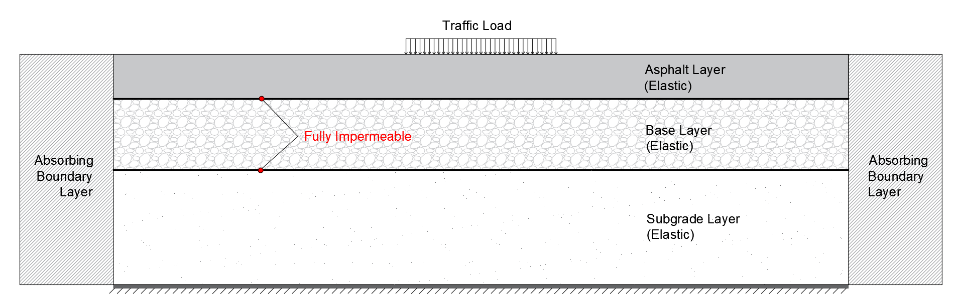

**Fig.1** Model of 2D PEFIT

Table 2 lists input parameters for 2D plane strain and 3D axisymmetric cases. For 3D case, high load speed (60 mph) and low permeability level (hydraulic conductivity 0.0077 in/s) are considered, and the radius of loading area is 4 inches.

**Table 2**. Basic input parameters

|  |  |  |  |  |  |  |  |
| --- | --- | --- | --- | --- | --- | --- | --- |
| Size (in) | dt | Speed (mph) | Absorbing factor | Total calculated time (s) | Mesh size | load moves forward each time | Soft landing for both systems? |
| 800 x 89 (3+6+80) | 1E-06 | 60  (1000 in/s) | 0.000045 | 0.4 | 1 x 1 | 2 | Yes |

1. **Comparison between 2D PEFIT and 3D axisymmetric case using same parameters (load length and hydraulic conductivity).**

Model with 8 inches load length and hydraulic conductivity of 0.0077 in/s (same parameters used in 3D case) was conducted first and results are plotted in Figure 2, where both vertical stress and pore pressure are significantly greater in 2D case.

|  |  |  |
| --- | --- | --- |
| Base Top |  |  |
|  | (a1) Vertical stress | (a2) Pore pressure |
|  |  |  |
| Base Middle |  |  |
|  | (b1) Vertical stress | (b2) Pore pressure |
|  |  |  |
| Base Bottom |  |  |
|  | (c1) Vertical stress | (c2) Pore pressure |

**Fig. 2** Comparison between 2D and 3D cases (same parameters)

1. **Preliminary parametric study**

Based on results in figure 2, the parametric study of 2D PEFIT with decreasing load and increasing hydraulic conductivity (Table 3) was performed. In the following test, only one of two parameters is varied, the fixed parameter always uses the same value as of 3D axisymmetric case.

**Table 3**. Parametric study on loading length and hydraulic conductivity

used in axisymmetric case

|  |  |  |
| --- | --- | --- |
| Load length (in.) | Hydraulic conductivity (in/s) | b |
| 8 | 0.0077 | 4.68 |
| 1 | 0.018 | 2 |
| 2 | 0.036 | 1 |
| 3 | 0.06 | 0.6 |
| 4 | 0.12 | 0.3 |

**3.1 Hydraulic conductivity (HC) fixed, load length (L) varies**

The hydraulic conductivity is **0.0077 in/s fixed**, and the **load length** varies as 1,2,3,4 and 8 inches. Findings (horizontal red lines) from Figure 3 a1, b1 and c1 are concluded as:

1. For base top, load length should be around 4 inches.
2. For base middle, load length should be between 3 and 4 inches.
3. For base bottom, load length should be between 2 and 3 inches.

Note: for L=0.5, please refer to the appendix part 4, Figure 11.

|  |  |  |
| --- | --- | --- |
| Base Top |  |  |
|  | (a1) Vertical stress | (a2) Pore pressure |
|  |  |  |
| Base Middle |  |  |
|  | (b1) Vertical stress | (b2) Pore pressure |
|  |  |  |
| Base Bottom |  |  |
|  | (c1) Vertical stress | (c2) Pore pressure |

**Fig. 3** Dynamic responses, HC fixed

From plots of pore pressure in Figure 3, it is noticed that when load length (L) is 1 in., 2D PEFIT yields the closet result to 3D axisymmetric case. To further examine, an individual comparison is plotted in Figure 4.

|  |  |
| --- | --- |
| Base top |  |
|  | (a) |
| Base middle |  |
|  | (b) |
| Base bottom |  |
|  | (c) |

**Fig. 4** Comparison of pore pressure between 2D (L=1) and 3D

Based on Figure 4, some additional attempts are made on slightly increasing HC from 0.0077 in/s to 0.009 in/s, 0.012 in/s and 0.015 in/s to try to better match **middle and bottom** pore pressure with 3D case (in Figure 4, top results are match up well). In Figure 5 b.1 and c.1, HC =0.015 in/s provides most closet results, and individual comparisons are plotted in Figure 5 b.2 and c.2.

|  |  |
| --- | --- |
| Base top |  |
|  | (a) |

|  |  |  |
| --- | --- | --- |
| Base middle |  |  |
|  | (b1) | (b2) |
| Base bottom |  |  |
|  | (c1) | (c2) |

**Fig. 5** Dynamic pore pressure varies with HC

**3.2 Load length fixed, hydraulic conductivity (HC) varies**

The **load length is fixed 8** inches as in 3D case, and the **hydraulic conductivity** varies as 0.0077 in/s,0.018 in/s, 0.036 in/s,0.06 in/s,0.12 in/s.

In plots of Figure 6 a1, b1 and c1, red line denotes vertical stress of 3D case, and all other lines of 2D results overlap with pink line, which shows that HC does not affect vertical stresses.

|  |  |  |
| --- | --- | --- |
| Base Top |  |  |
|  | (a1) Vertical stress | (a2) Pore pressure |
|  |  |  |
| Base Middle |  |  |
|  | (b1) Vertical stress | (b2) Pore pressure |
|  |  |  |
| Base Bottom |  |  |
|  | (c1) Vertical stress | (c2) Pore pressure |

**Fig. 6** Dynamic responses, L fixed

**Appendix**

1. Sensitivity analysis of Load length (L)

Figure 8 presents sensitivity analysis of hydraulic conductivity at load length 1 and 2 inches at base top.

|  |  |  |  |
| --- | --- | --- | --- |
| HC: **0.12 in/s** |  |  |  |
|  | Base top | Base middle | Base bottom |
| HC: **0.06 in/s** |  |  |  |
|  | Base top | Base middle | Base bottom |
| HC:  **0.036 in/s** |  |  |  |
|  | Base top | Base middle | Base bottom |
| HC:  **0.018 in/s** |  |  |  |
|  | Base top | Base middle | Base bottom |

**Fig. 7** Pore pressure under various HC

|  |  |  |
| --- | --- | --- |
| Base top |  |  |
| Base middle |  |  |
| Base bottom |  |  |

1. Sensitivity analysis of HC

**Fig. 8** Dynamic response of pore pressure varies with load length and HC

1. Distance effect on initial pore pressure

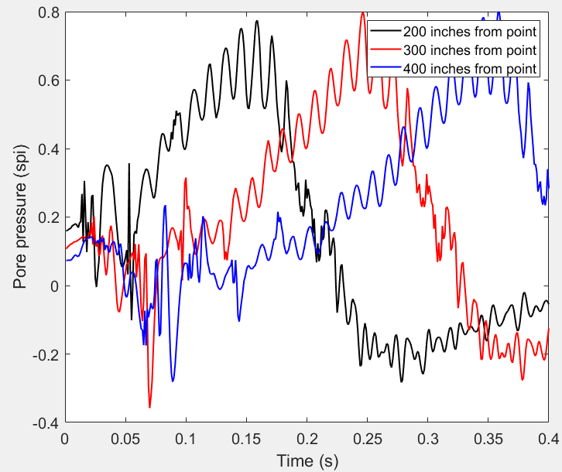

**Fig. 9** Distance effect on initial pore pressure

1. L=0.5 in, HC=0.0077 in/s

By using load length as 0.5 in., the mesh size changes to 0.5 in. x 0.5 in., also since the load can now only moves forward one grid at a time, the load slope (loading/unloading process) is twice as that of former cases.

|  |  |  |
| --- | --- | --- |
| Base top |  |  |
|  |  |  |
| Base middle |  |  |
|  |  |  |
| Base  bottom |  |  |

**Fig. 10** Dynamic responses of load length 0.5 in.